University Institute of Technology RGPV, Bhopal (M.P.),462033

Department of Computer Application



Session: 2020-21

**Minor Project - II**

**Report File**

Submitted in partial fulfillment for award of degree of

Masters of Computer Application

E-Complain

A Web Based Application

-------Submitted By-------

Ayush Chorasiya (0101CA193D06)

Mohammad Ajmal Siddiqui (0101CA193D13)

Prashu Jain (0101CA193D14)

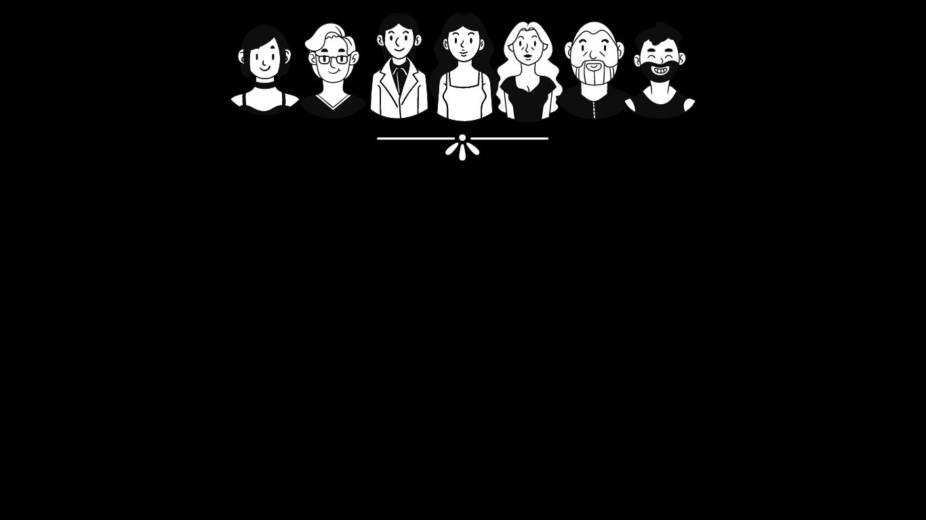

**COMPLAIN PORTAL**

E-Complain is a web-based System that takes the Complain of the user and process it.

This website is design with the purpose for promoting the Online Awareness among the people to Complain their issues regarding to the any of the cases, in case of emergency and this great Pandemic Corona Virus.

The web complaint management website allows the user to record the complaint and loads it to the complaints database. It offers a strategic method for online lodging and tracking of customer concerns and issues. You can access each complaint's history and check the status update.

All these features include the ability to complaint about various issues. It also contains a report generation system that can be saved in a pdf file format.

**Scope of the Work**

Registration of complaint: Peoples will have access to their personal profiles and will be able to create new complaints and edit their complaints.

Complaints Management: All complaints will be forward to government within 24 hours to solve that problems as soon as possible.

Report generation: The software manager will be able to generate timely reports in order to monitor complaints and this can be used for performance appraisals. The reports will be having all the information of an action taken on complaints.

**Project Modules and Implementation modules**

There are many different- different modules used in this project.

Let's discuss all modules one by one →

1. Firstly, we will discuss about our website front page. In this module will have given registration and login page by which existing peoples can login their account and new peoples can register in our website.
2. After login and registration , we have work on that module by which peoples can complaint about any problems and we have also provide their different different categories for different different kinds of problems.
3. After that we have work on our data base for storing complaint of peoples in our backend.
4. In this module we work for conneting with peoples to solve thier problems as soon as possible.

**Requirement for this Site**

* Some peoples with the issues are not very comfortable opening with the human directly. They are comfortable filing their issues anonymously and with less human interaction.
* Main focus of this site is these people. So, they can share and not feel cornered.
* This system provides that infrastructure by requiring very less interaction with the human being.

**Advantages of this Project**

All Peoples are able to complaint about any peoples issues to the government within a second.

After registering is granted to the system, the peoples can easily add a new problem to the system by entering the basic information which are the full names and email address and problems statement.

During the process of user registration, the all users are issued with a unique username and password combination.

Seeing that the system holds private complaint information, the government has the ability to monitor all complaint logs into the system by date and time.

The newly added users logs into the system with a default password which can later be changed to a more secure passwords.

Peoples can apply for new complaint by filling in a form as well as submitting a attachment to support their complaint request.

**Future Scope and further enhancement of the Project**

Complaint Management website -The complaint management website will be able to solve all issues and problems which are facing by the peoples as soon as possible. Our elders will not have to face any problems to registing complaint.

With the help of our website any human can easily complaint about any problem.

Functionality

* Awareness
* This site Encourage people to open up in the society
* This site contain various types of form of complains.
* These forms takes the user details and their complain.
* Process the complain
* And store it into database.

Technology used in this project

* Front End Development
  + HTML

HTML stands for Hyper Text Mark-up Language

HTML is the standard mark-up language for creating Web pages

HTML describes the structure of a Web page

HTML consists of a series of elements

HTML elements tell the browser how to display the content

HTML elements label pieces of content such as "this is a heading", "this is a paragraph", "this is a link", etc.

* + CSS

CSS stands for Cascading Style Sheets

CSS describes how HTML elements are to be displayed on screen, paper, or in other media

CSS saves a lot of work. It can control the layout of multiple web pages all at once

External stylesheets are stored in CSS files

CSS is used to define styles for your web pages, including the design, layout and variations in display for different devices and screen sizes.

* + JavaScript

JavaScript is the world's most popular programming language.

JavaScript is the programming language of the Web.

JavaScript is easy to learn.

**JavaScript** is to program the behaviour of web pages

JavaScript Can Change HTML Content

JavaScript Can Change HTML Attribute Values

JavaScript Can Change HTML Styles (CSS)

JavaScript Can Hide HTML Elements

JavaScript Can Show HTML Elements

* + JQuery
* Back End Development
  + PHP
  + phpMyAdmin
  + MySql

**Conclusion**

This Chapter has specified the design, implementation and working of the E-complaint website.

People will submit their common problem to the government, which will be helping government only to serve public in a better way.

It will provide the direct contact to head offices directly by an individual.

No intermediate delay will occur.